Helpful formulas and information

1 km = 103 m

1 mm = 10-3 m

1 m = 10-6 m

1 nm = 10-9 m

**For constant acceleration**

**Linear momentum**

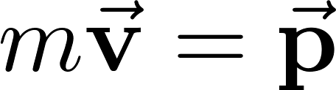

**Impulse**

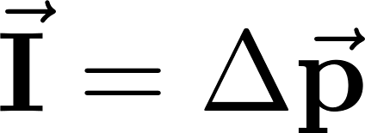

**Center of mass**

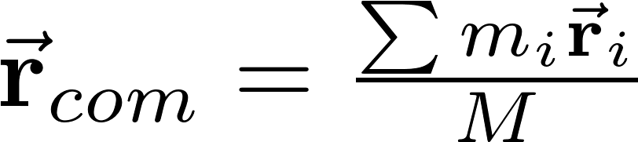

**Torque**

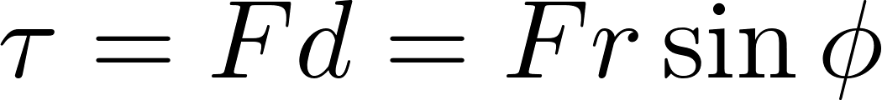

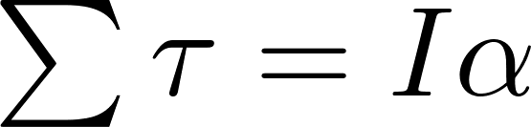

**Moment of Inertia**

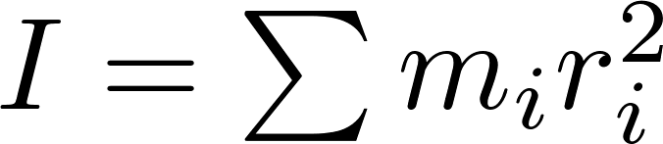

**Parallel-Axis Theorem**

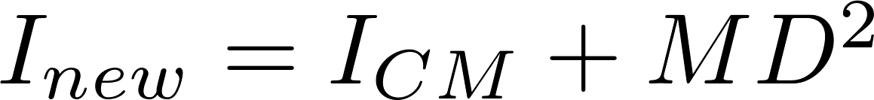

**Rotational kinetic energy**

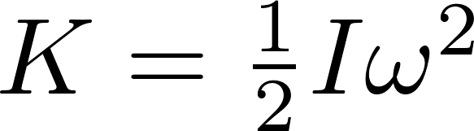

**Angular Momentum**

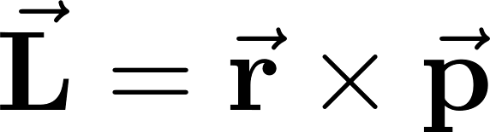

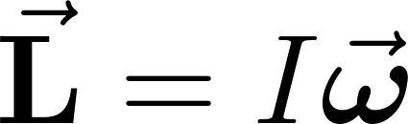

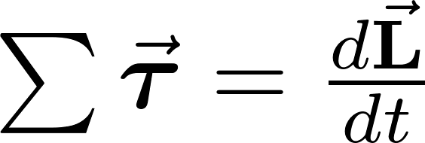

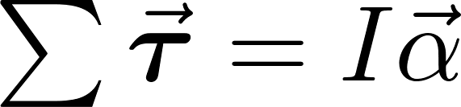

$x_{f}=x_{i}+v_{i}t+\frac{1}{2}at^{2}$

$v_{f}=v_{i}+at$

**For circular motion**

, 

**Friction**



**Resistive Force**

For low speeds

R = -bv

For high speeds

R = ½ DrAv2

**Work**



For varying force



**Force for a spring**

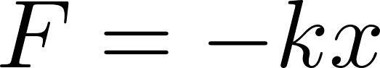

**For conservative force**

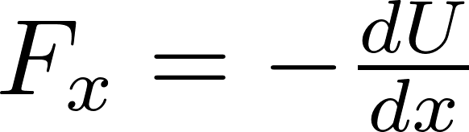

**Kinetic energy**

